SCP Infiltration – Design Document

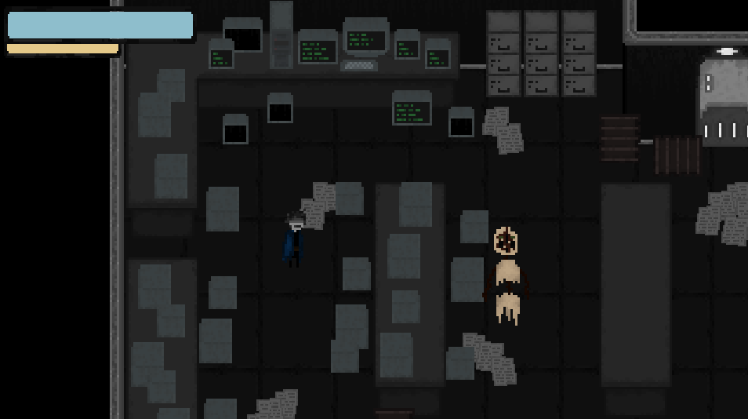

*SCP: Permafrost*

*https://gamejolt.com/games/Permafrost/784002*

**Game Identity / Mantra**

2D top-down pixel art dungeon style action horror shooter. You are an SCP Foundation MTF operative who must break into site 03 after contact was cut off with the site during a containment breach. You come across zombies and SCP enemies to fight as well as human NPCs that may help you or need to be helped.

**Design Pillars**

1. Top down 2D (3/4 view).
2. Must be able to shoot a weapon at zombies.
3. Must use a tilemap to set up rooms.
4. Must have *some kind* of puzzle for the player to solve.
5. Must have dialogue to help guide the player.

* **Genre:** 2D top down ¾ action horror Hybrid (only hybrid if time allows).
* **Story:** You are an operative of the secretive SCP Foundation. All contact has been lost with Site 03 and you, a Mobile Task Force specialist, have been sent in to assess the threat, save foundation personnel, contain SCPs, and recover classified documents before they can fall into the wrong hands. Upon entering the player learns that the base has fallen under the siege of SCP-008, which acts like a zombie contagion. The player must take up arms and fight their way through the base to complete their mission.

While contact from outside the base may have been lost, the plan is to have areas in which the player may be able to find survivors of the attack on the base, or where alternatively they may be able to find radios that are playing messages from survivors, or notes and documents that have been left behind.

The player will be commanded to protect who they are able to but focus on the main mission of recovering classified documents from the scene and securing what SCPs they can.

The plan is for this to act as a smaller demo, the last scene of which being the player being guided into the chamber of SCP-173, where they will be left and presumably attacked (offscreen), and the demo will end.

* **Mechanics:** I have a lot of ideas that I am going to try to either develop or toss out over time but for now I’m going to throw them all here and see which might be recommended for someone who has programmed a bit of Unity before.
  + A gun system in which the player starts with a pistol and can unlock a rifle or shotgun later and pickup ammo for all weapons.
  + The ability to interact with certain in game objects using the F key. Objects might include radios broadcasting a message throughout the site, notes left behind by survivors, research documents, ammo to pick up, NPCs to talk to, doors to open / unlock / go through, or objects that must be interacted with to open doors or otherwise effect the in-game world.
  + The ability for zombies to track the player. If possible, it would be nice to make them go around walls or through doors, but I would need to look up a tutorial for this if it isn’t included in class scripts.
  + This one is my biggest tasks (so I don’t expect it but I hope ill have time for it), I think it could add some fun to the game if I am able to do this correctly: Among Us style task screens such as a keycard swipe, passcode entry etc. These would act as small puzzles where the player may sometimes have to go search for a clue about that puzzle, i.e., a pattern for a special padlock. (new note: I already have one working so the others should be fast to make 😊)
  + The ability to affect the world in different ways i.e., opening doors by pushing a button in a faraway place or another room.
  + This one is another larger task so it would be something I either try to do in my own spare time or would try once everything else is made: it would be cool to try to figure out a way to string rooms together procedurally instead of manually.
  + A text overlay system to tell the player key information instead of always using a dialogue pop up, ie “You picked up an Engineers Keycard”
  + Possible to have NPCs that require some kind of help to escape the site, ie. They need a researcher level key card, so you need to find one.

**Game Flowchart:** Layout the *KNOWN* content of your game.

Quit Screen

Game over

Credits Screen

Listing of all credits

Game Start Screen

Button based Start, Quit, Credits

Game End

Player enters final room and is (offscreen) killed by an SCP, demo ends.

Level 3

Heavy Containment Zone: player introduced to one SCP, still fights zombies. must find keycard, documents, puzzles and passcode to decipher puzzle and escape the site.

Level 1

Entrance Zone: Player must find keycard and other puzzles to open the gate to zone 2.

Level 2

Light Containment Zone: player introduced to zombies. must find keycard and passcode to enter zone 3.

Transition 1

Opening cutscene / text crawl. Player begins in first zone.

**Features**

**Key:**

Not Started

Art Created

Asset Partially Created / Programmed

Asset Created and Programmed

**Critical Assets – Characters**

* Player with 4 directional movement
* Human characters
* Zombie characters with 4 directional movement

**Critical Assets – Environment/Props**

* Tile maps for: Entrance Zone, Light Containment Zone, Heavy Containment Zone.
* Objects to interact with.
* Doors that open / close
* Furniture

**Critical Assets – Gameplay**

* Zombies
* Interactable object screens (switches, buttons, etc.)
* `Doors
* Dialogue system
* Ammo and health items

**Interface**

* Hearts for health
* Ammo counter for weapons
* Dialogue boxes and portraits.
* Weapons / weapon sprites

**Art Style**

**Character Reference**

(Visual reference for the Player, NPCs, Enemies, Companions, any interactive entities).

**Environment Reference**

(Visual reference for the world your game takes place in).

**Interface Reference**

(Visual examples of the various UI elements your game requires.

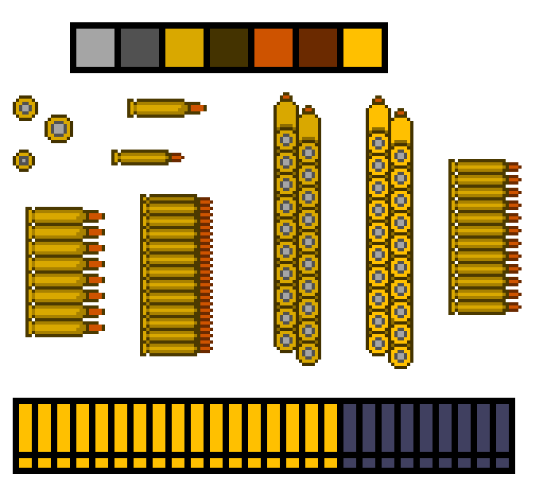 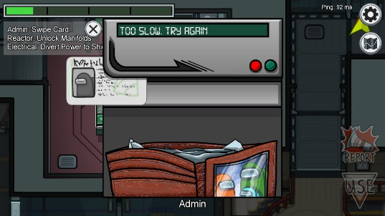

**Current State of Art / Assets**

**Characters**

There are currently 8 character types, that I have sprites and portraits for both male and female variants as well as human and zombie variants.

**Tilemap**

There are currently 3 tilemaps ready for each SCP site zone (entrance zone, light containment, heavy containment).

**UI Elements**

There are currently: items, minigames (partially created), weapons, a heart, ammo, and a font created.

**Programming**

(I have also started the programming and currently have player animations, large doors that open when all required buttons are pressed, items that the player can pickup and store in an inventory, and the minigames have the core functionality ready, so I just have to code the specific parts of each game.)

**Audio**

1. Player/NPC footsteps
2. Player taking damage
3. Zombies taking damage
4. Bullet sounds
5. Door opening (large sliding door and one with hinges)
6. Alarm Noise
7. Ambient noises
   1. Office setting
   2. People talking
   3. Panic / people yelling
8. Radio noises
9. Interaction noises
   1. Computer boot up
   2. Snipping noise
   3. Button pressed noise
   4. Good / Bad puzzle noise (ie. when a keypad gets the right/wrong combination)

**Development Roadmap**

**Platform:** PC **Audience:** T

**MISSION 02 – GDD v1.0:** 9/10/2023

**MILESTONE 01 - Prototype:** 9/24/2023

**MILESTONE 02 - Midterm:** 10/15/2023

**MILESTONE 03 - Beta:** 11/12/2023

**MILESTONE 04 - Gold:** 12/6/2023